Output Screens

# 1) Game Start:

This screen serves as the initial interface when the game is launched. It typically includes options to start the game, choose game settings, and navigate to other screens like choosing tokens or exiting the game.

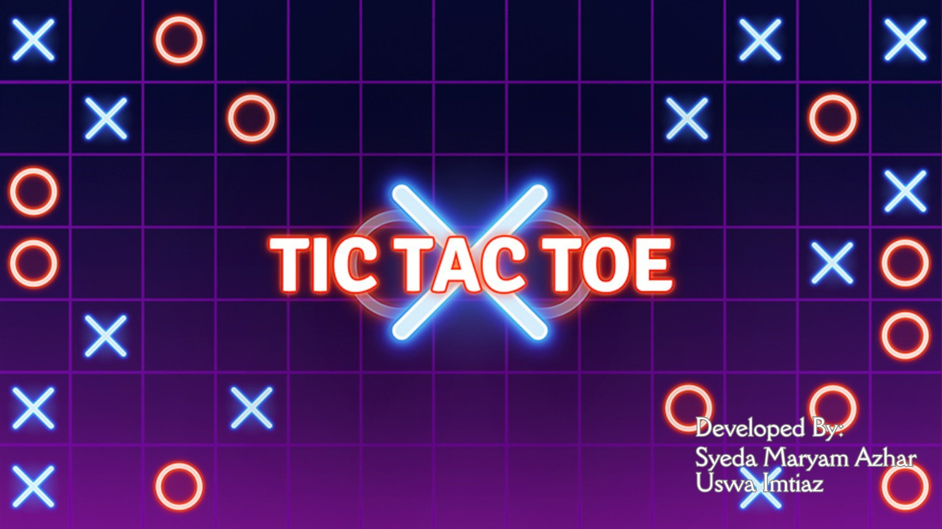

# 2) Choose Token:

In this screen, the player can select his/her preferred token (X or O). The choosen token is assigned to the Player and the other token is assigned to the Computer.

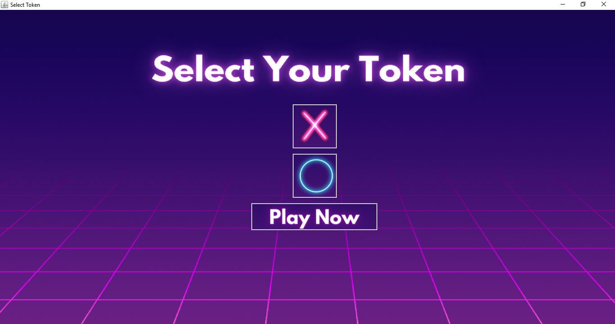

# 3) Grid:

The grid screen displays the current state of the game board. It showcases the positions of the X's and O's placed by the player and the computer. Player interacts with this screen to make their moves by selecting an empty cell to place their token.

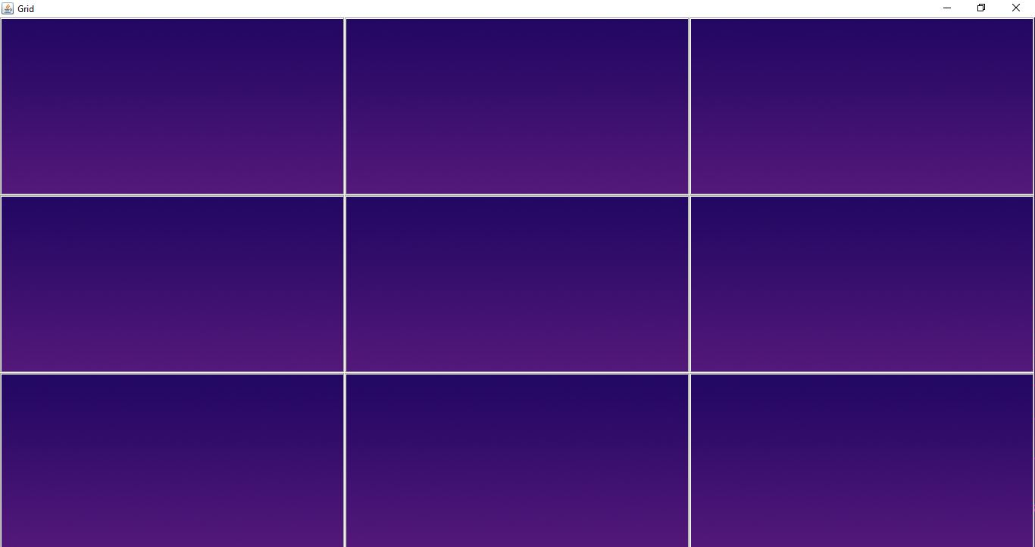

# 4) Turns:

The player and the Computer take turn to place token on the grid. An error message is displayed if the player tries to place token on an occupied box.

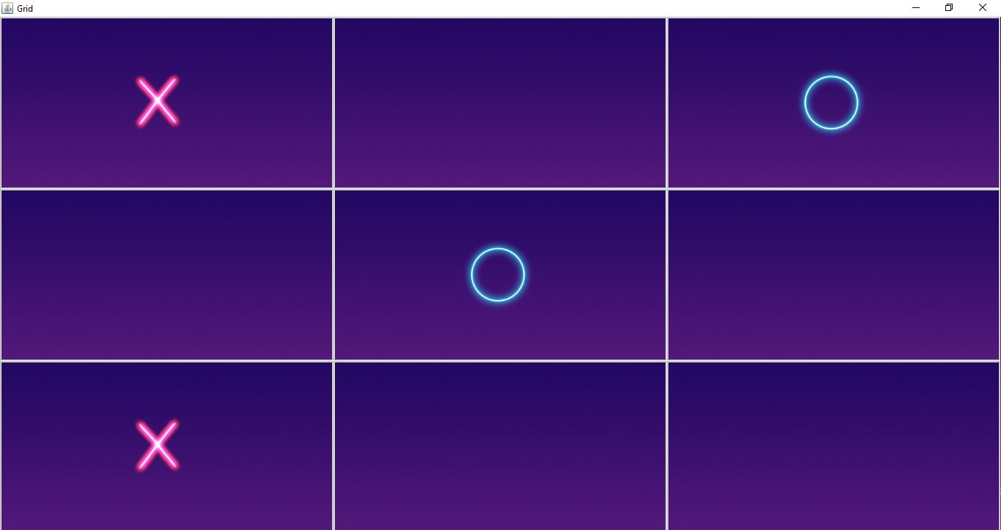

It displays error message if user tries to place token on an already selected area in the grid.

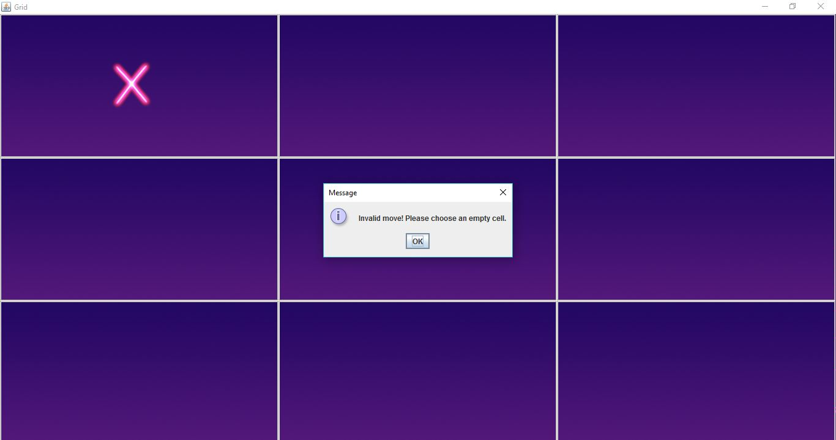

# 5) Win:

When the game concludes with a win by either the player or the computer, this screen appears to announce the winner. It displays a congratulatory message which tells if either the player or the computer has won.

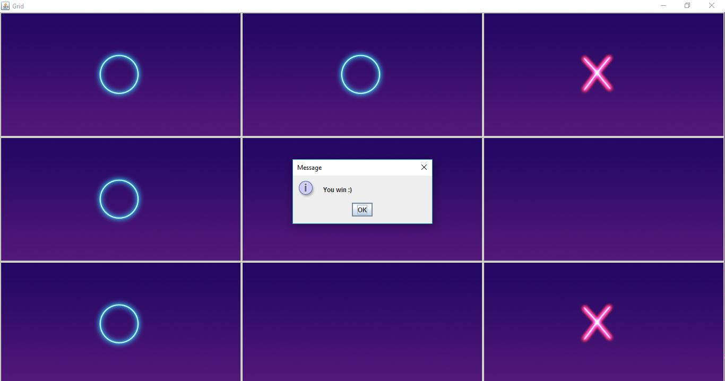

# 6) Draw:

If the game ends in a draw with none achieving a winning combination, this screen notifies the players about the draw outcome.

